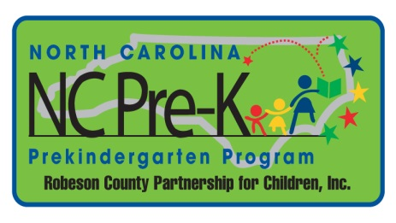
Robeson County Partnership for Children, Inc.
Robeson County NC Pre-K Enhancement Funds*

The following guidelines have been adopted by the Robeson County Pre-K Committee as guidance for enhancement funds. Enhancement funds are based solely on need. The Robeson County Pre-K Committee must approve all use of enhancement funds, unless otherwise approved by the committee. All requests must be presented to the Robeson County NC Pre-K Committee using the Robeson County Enhancement Funds application.

Enhancement funds may be awarded in the following ways:

- New NC Pre-K Sites may need startup funds to meet NC Pre-K and ECERS requirements. RCPC staff will evaluate the need as new classrooms open and will make necessary requests to the Robeson County Pre-K Committee. As a general rule, no more than $500.00 per child will be requested.

- Existing NC Pre-K Sites may need financial assistance upgrading classroom and playground equipment to maintain the high level of quality expected by the General Assembly and DCDEE. During annual site monitoring visits, RCPC staff will document upgrade needs and share with the Site Director. If the site cannot fill the request in full, the
NC Pre-K Specialist may request enhancement funds for classroom or playground upgrades. As a general rule, no more than $500.00 per child will be requested.

- The Robeson County Pre-K Committee has the authority to allocate enhancement funds on a case-by-case basis as unique challenges are presented.

*These guidelines adhere to local Robeson County NC Pre-K Enhancement Funds. The Governor’s Office/DCDEE, may allocate startup funds for new children or sites and the guidelines attached to the funds will be followed accordingly.

