2016 Beautiful Baby Princess

*Anna Caroline Branch*

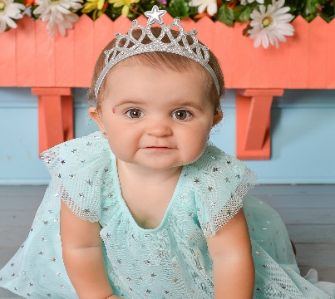

2016 Beautiful Baby Prince

*TJ Little*

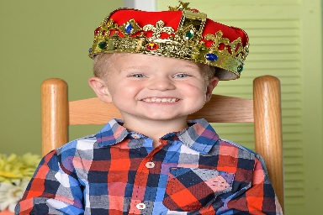

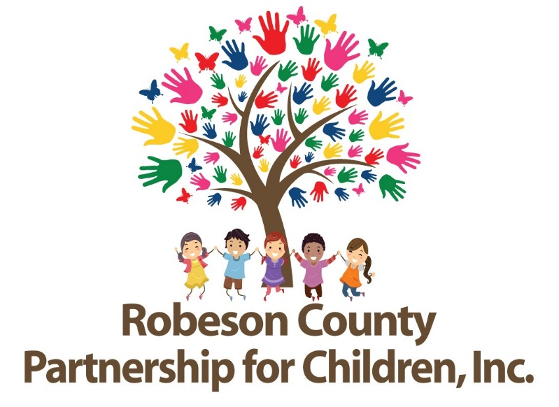

__________________________________________________________________

**Robeson County Partnership for Children**Committed to preparing young children for long-term educational, health, and economic success.

[www.robesonpartnership.org](http://www.robesonpartnership.org)  
Questions? Please contact Tim Little @ 910-738-6767 or funddevdir@rcpartnership4children.org

Baby Contest

**Winners…**…will be announced in the Father’s Day edition of *The Robesonian*.   
  
The top 12 babies will be featured in the 2018 calendar scheduled for release in the fall.

Two (2) 1st place winners, one male and one female, will be chosen.

**1st place winners receive $100 Cash, Crown or Tiara, Parade Magnet, & Trophy  
2nd-6th place winners receive a Trophy**

**Do you have the most beautiful baby in Robeson County?  
Show off your prince or princess by entering the Beautiful Baby Contest.**

To enter, go to [www.robesonian.com/section/contests](http://www.robesonian.com/section/contests).   
Complete the entry information, upload your favorite candid photo. Registration is $20 per child.

Registration begins **April 10, 2017** and ends **May 5, 2017**.

Ages of entry are birth to five years of age (no kindergarteners please).  
Parents, grandparents, or guardian must be residents of Robeson County to enter.

Have family and friends vote   
 by mail or in person at our office location 210 E. 2nd St., Lumberton, NC 28358, or online at robesonpartnership4children.org

**All Votes are $1.00 each.**

**Do you have the most beautiful baby in Robeson County?  
Show off your darling by entering the Beautiful Baby Contest.**

To enter, go to [www.robesonian.com/contests](http://www.robesonian.com/contests). Complete the entry  
information, upload your favorite candid photo. Registration is $20 per child.

Registration begins April 14 and ends on May 6.

Ages of entry are birth to five years of age (no kindergarteners please).  
Parents, grandparents, or guardian must be residents of Robeson County to enter.  
  
Have family and friends vote at [www.robesonpartnership.org](http://www.robesonpartnership.org)  
By mail or in person at Robeson County Partnership for Children  
210 E. 2nd St., Lumberton, NC 28358

**All Votes are $1.00 each.**

**Do you have the most beautiful baby in Robeson County?  
Show off your darling by entering the Beautiful Baby Contest.**

To enter, go to [www.robesonian.com/contests](http://www.robesonian.com/contests). Complete the entry  
information, upload your favorite candid photo. Registration is $20 per child.

Registration begins April 14 and ends on May 6.

Ages of entry are birth to five years of age (no kindergarteners please).  
Parents, grandparents, or guardian must be residents of Robeson County to enter.  
  
Have family and friends vote at [www.robesonpartnership.org](http://www.robesonpartnership.org)  
By mail or in person at Robeson County Partnership for Children  
210 E. 2nd St., Lumberton, NC 28358

**All Votes are $1.00 each.**

Beautiful