Robeson County Partnership for Children, Inc. (RCPC)
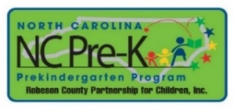

Robeson County Special Called NC Pre-K Committee Meeting
September 11, 2017
RCPC Board Room
Immediately following the RCPC Board of Directors Meeting that begins at 12:00 p.m.

Purpose
Consultation with attorney regarding pending litigation.

