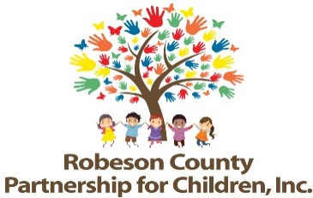

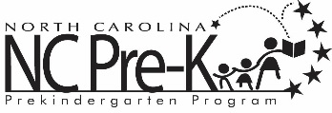
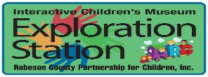

Grants Review Committee Meeting
January 10, 2019
RCPC Board Room
Immediately Following Proposal Conference

Approval of Minutes
Review minutes from the November 8, 2018 committee meeting.

Action Items

- FY 2019-2021 Annual Submissions to NCPC
Background: RCPC advertises Requests for Proposals (RFP) for two year bid cycles. Following submission deadline, the Grants Review Committee and staff conduct panel interview sessions with potential bidders. Once panel interviews are conducted, the Grants Review Committee attends a proposal conference to review, discuss, and score proposals.

Issue: The committee will review, discuss, and score proposals and recommend activities for FY 2019-2020 annual submission and FY 2020-2021 annual submission.

Recommendation: The Grants Review Committee’s recommendations for inclusion in RCPC’s annual submission to NCPC for FYs 2019-2021 are as follows:

Activity | Score | Recommendation
- Environment Quality Star Tracks
- Professional Development Services
- Nurse Family Partnership
- Parents As Teachers

Activity | Score | Recommendation
- Dolly Parton Imagination Library
- NC Pre-K Transportation
- Ready, Set, Go
- Color Me Healthy for SNAP-Ed

- Program Coordination, Evaluation and Community Outreach | Score not required by NCPC
- *Subsidy | Not Applicable | No Action Required

- FY 2019-2021 Budget Recommendations to Executive Committee
Background: The Grants Review Committee reviews proposals, in detail, upon submission. The Grants Review Committee’s comprehensive review can provide supportive guidance to the Executive Committee in making decisions regarding budget amounts.

Issue: The committee will review, discuss, and recommend activity budgets for FY 2019-2020 and FY 2020-2021 to be presented to the Executive Committee.

Recommendation: The Grants Review Committee’s budget amount recommendations for FYs 2019-2021 are as follows:

Activity | Current 2018-2019 Budget | Amount Requested  2019-2020 2020-2021 |  | Justification for Increase/Decrease  (if requested) | Budget Amount Recommendation to Executive Committee
- Environment Quality Star Tracks | $230,043 | $223,116 | $223,116 | Contracted services
- Professional Development Services | $287,765 | $287,765 | $287,765
- Nurse Family Partnership | $106,238 | $107,884 | $107,884 | Personnel costs
- Parents as Teachers | $142,763 | $144,354 | $144,354 | Office supplies, travel, non-cash grants

Activity | Current 2018-2019 Budget* | Amount Requested  2019-2020 2020-2021 |  | Justification for Increase/Decrease  (if requested) | Budget Amount Recommendation to Executive Committee
- Dolly Parton Imagination Library | $5,000 | $10,000 | $10,000 | Additional children
- NC Pre-K Transportation | $154,898 | $182,898 | $182,898 | Original funding amount
- Ready, Set, Go | $123,403 | $125,800 | $125,800 | Personnel costs
- Color Me Healthy for SNAP-Ed | $53,286 | $62,704 | $62,704 | Original funding amount (full year of funding vs partial)
- Program Coordination and Community Outreach | $138,770 | $210,678 | $210,678 | Staff reallocations
- Program Evaluation | $80,908
- Fundraising | $19,691 | $28,000 | $28,000 | NCPC Mandated activity (full year of funding vs partial)
- Partnership Administration | $210,663 | $210,663 | $210,663
- Subsidy | $1,069,239* | $1,052,239 | $1,052,239 | Original funding amount
- Subsidy Administration | $52,062 | $61,211 | $61,211 | Personnel costs, materials & equipment
- Unallocated | $10,000
Total Amount Allocated | $2,684,729* | $2,707,312 | $2,707,312 |  | $2,677,729
*Totals include $7,000 of carryover funds that are not recurring beyond the 2018-2019 FY.

- First Quarter Progress Report
Background: The Grants Review Committee is responsible for reviewing activity progress each quarter.
Issue: The first quarter progress report is included for review.
Recommendation: The committee should review and consider approving the first quarter progress report.
- First Quarter Score Card
Background: The Grants Review Committee is responsible for reviewing activity progress each quarter.
Issue: The first quarter score card is included for review.
Recommendation: The committee should review and consider approving the first quarter score card.
Non Action Items
- Recommendations for future RFP submissions and GR Proposal Conference

Next Meeting Date:
The next meeting is scheduled for Thursday March 14, 2019 at noon at RCPC.

Adjournment
Thank you for your commitment to RCPC, the review process, and the children and families of Robeson County!

