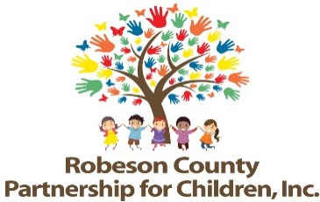

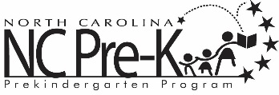

Grants Review Committee Proposal Conference
January 10, 2019
RCPC Board Room
9:00 a.m.

RCPC advertises Requests for Proposals (RFP) for two year bid cycles. Following submission deadline, the Grants Review Committee and staff conduct panel interview sessions with potential bidders. Once panel interviews are conducted, the Grants Review Committee attends a proposal conference to review, discuss, and score proposals.

