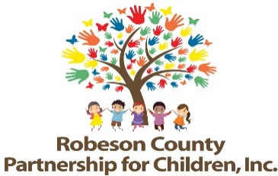

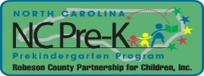

Grants Review Committee Meeting
September 13, 2018
RCPC Board Room
12:00 p.m.

Approval of Minutes
Review minutes from the March 27, 2018 committee meeting.

Action Items
- Third Quarter Progress Report & Score Card
Background: The Grants Review Committee is responsible for reviewing activity progress each quarter.
Issue: The third quarter evaluation report and score card is included.
Recommendation: The committee should review and consider approving the third quarter progress report and score card.
- Fiscal Year 2017-2018 Final Evaluation Report & Score Card
Background: The Program and Evaluation Department reviews data and supporting documentation for each funded activity and compiles a cumulative final evaluation report. The report details outputs, outcomes, barriers, challenges, and successes.

Issue: The final evaluation report and score card for FY 2017-2018 is presented for review.

Recommendation: The committee should review and consider approving the final evaluation report and score card and submit to the Board of Directors for approval.

- Ask Why Responses
Background: The Board of Directors must approve Ask Why Responses.

Issue: The Ask Why Responses for the Final 2017-2018 Score Card are presented for review.

Recommendation: The committee should review and consider approving the Ask Why Responses.
Non-Action Items

Announcements

Adjournment
The next meeting will be held on Thursday, November 8, 2018.

