Robeson County Partnership for Children, Inc. (RCPC)

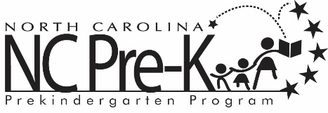

Robeson County NC Pre-K Co-Chair Meeting
April 9, 2019
RCPC Conference Room
Immediately following the NC Pre-K Committee Meeting
that follows the RCPC Board Meeting

Call to Order

Public Comment

Discussion: Appointment of NC Pre-K Committee members for 2019-2020.

Adjournment

