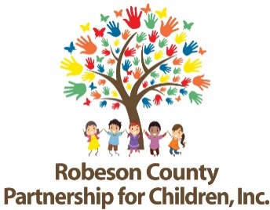
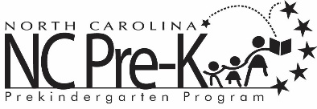

Robeson County Partnership for Children NC Pre-K Contact List
NC Pre-K Contacts | Roles and Responsibilities
Rhiannon Chavis-Wanson  Program Manager  910-738-6767 ext. 285  rchaviswanson@rcpartnership4children.org | NC Pre-K Program Management
Erika Nolley  NC Pre-K Specialist  910-738-6767 ext. 286  enolley@rcpartnership4children.org | Transportation, Application Approval, Teacher Placement, Technical Assistance
Victoria Meggison  Program Associate  910-738-6767 ext. 297  vmeggison@rcpartnership4children.org | Application Approval, Child Placement,  Slot Maintenance
Diana Strickland  Program Assistant  910-738-6767 ext. 292  dstrickland@rcpartnership4children.org | Attendance, Applications, Health Assessments, Dental, & Developmental Screenings
Amanda Lovette  Quality Enhancement Specialist  910-738-6767 ext. 291  alovette@rcpartnership4children.org | Technical Assistance
Betty Brum  Quality Enhancement Specialist  910-738-6767 ext. 290  bbrum@rcpartnership4children.org | Technical Assistance
Lindsay Mejia  Finance & Contract Specialist  910-738-6767 ext. 224  lmejia@rcpartnership4children.org | Contracts and Reimbursement

For general questions concerning Robeson County’s NC Pre-K program, please contact the receptionist at 910-738-6767.

