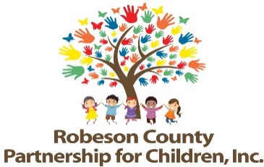

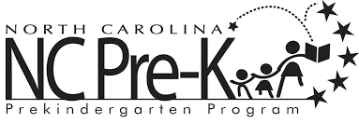

Grants Review Committee Meeting
January 9, 2020
RCPC Board Room
12:00 p.m.

Approval of Minutes
Review minutes from November 14, 2019 Committee meeting.

Committee Overview

Action Items
- First Qtr Progress Report & Score Card
Background: The Grants Review Committee is responsible for reviewing activity progress.
Issue: The 2019-2020 first quarter progress report and score card is included.
Recommendation: The committee should review and consider approving the first quarter report and score card.

- Ask Why Responses
Background: The Board of Directors must approve Ask Why Responses.

Issue: The Ask Why Responses for the Final 2018-2019 program year are presented for review.

Recommendation: The committee should review and consider approving the Ask Why Responses.

Non-Action Items

Activity updates from Sarah Heinemeier, Contract Evaluator

Announcements

Adjournment
The next meeting will be held on Tuesday, March 12, 2020.

