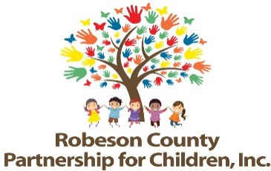

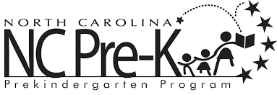

Grants Review Committee Meeting
November 14, 2019
RCPC Board Room
12:00 p.m.

Approval of Minutes
Review minutes from July 11, 2019 Committee meeting.

Committee Overview

Action Items
- Final Progress Report & Score Card
Background: The Grants Review Committee is responsible for reviewing activity progress.
Issue: The 2018-2019 final progress report and score card is included.
Recommendation: The committee should review and consider approving the final progress report and score card.

Non-Action Items

Activity updates from Sarah Heinemeier, Contract Evaluator

Announcements

Adjournment
The next meeting will be held on Tuesday, January 9, 2020.

