Robeson County Partnership for Children, Inc. (RCPC)
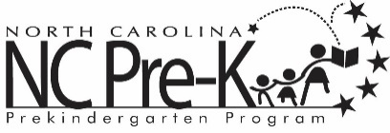

Robeson County NC Pre-K
Site Selection Subcommittee Meeting
January 23, 2020
RCPC Board Room
10:00 AM

The Robeson County NC Pre-K Program is conducting the site selection process for 2020-2022 school years. The Robeson County NC Pre-K Committee appointed a site selection sub-committee to conduct the process. Per DCDEE requirements, the sub-committee must review and score applications and make recommendations to the Robeson County NC Pre-K Committee for additional sites and/or classrooms.

