Robeson County Partnership for Children (RCPC)
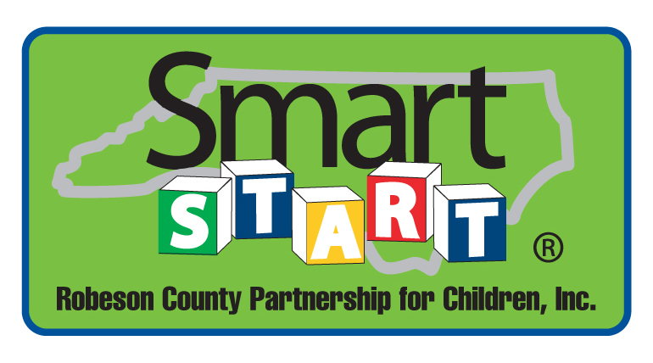
Nominations/Personnel Committee Meeting
May 30, 2018
RCPC Board Room
12:00 p.m.

Approval of Minutes
Review minutes from the March 28, 2018 committee meeting.

Action Items

1. Board Member of Excellence
Background: The Nominations/Personnel Committee makes selections for the Board Member of Excellence.

Issue: The committee should review the nominations.

Recommendation: It is recommended that the committee select a recipient.

2. Carla Bass Resignation
Background: Carla Bass is a current Board of Directors member.

Issue: Ms. Bass has offered her resignation from the Board effective June 30, 2018.

Recommendation: It is recommended that the committee consider approving the resignation effective June 30, 2018.

3. Board Member Nomination
Background: Due to NC Pre-K requirements, the NC Pre-K Committee must have a representative from the Department of Social Services.

Issue: Carla Bass will be resigning from the Board of Directors effective June 30, 2018. Linda Leggett has been named her successor by the Director of the Department of Social Services.

Recommendation: It is recommended that the committee consider approving Linda Leggett as the Department of Social Services representative for the NC Pre-K Committee and Robeson County Partnership Board of Directors.

Non Action Items
- Board Officer Structure
- FY 2019-2020 Board Members

Announcements
Adjournment

