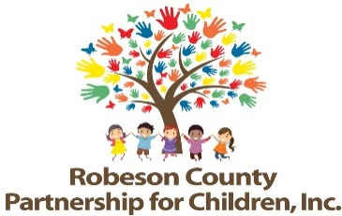

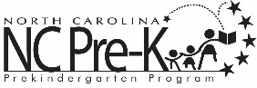

Nominations/Personnel Committee Meeting
March 27, 2019
RCPC Board Room
12:00 p.m.

Approval of Minutes
Review minutes from November28, 2018 committee meeting.

Action Items
- Bill Mauney Resignation
Background: Bill Mauney is a current member of the Board of Directors.

Issue: Mr. Mauney’s service on the board was directly tied to his position at Robeson Community College. Mr. Mauney retired at the end of December 2018 and has submitted his resignation from the RCPC Board of Directors.

Recommendation: It is recommended that the Nominations/Personnel Committee consider approving the resignation.

- Board Structure
Background: The Board of Directors must approve the slate each fiscal year.

Issue: The 2019-2020 proposed board slate is attached.

Recommendation: It is recommended that the committee review the proposed slate.

Announcements
Adjournment

