Robeson County Partnership for Children, Inc. (RCPC)
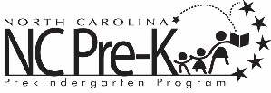

Robeson County NC Pre-K Committee Meeting
December 11, 2018
RCPC Board Room
Immediately following the RCPC Board of Directors Meeting that begins at 12:00 PM

Agenda

Closed Session with attorney regarding litigation per G.S. 143-318.11 (3), which states “To consult with an attorney employed or retained by the public body in order to preserve the attorney-client privilege between the attorney and the public body, which privilege is hereby acknowledged.”

