Robeson County Partnership for Children, Inc. (RCPC)

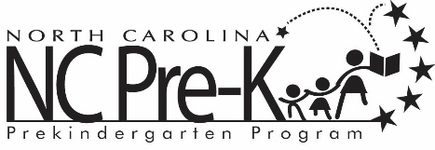

Robeson County NC Pre-K Committee Meeting
February 12, 2019
RCPC Board Room
Immediately following the RCPC Board of Directors Meeting that begins at 12:00 PM

Call to Order

Approval of Minutes
Review minutes from the August 14, 2018 committee meeting.

Action Items

- Annual Review of the Robeson County NC Pre-K Policies, Procedures, and Practices
Background: The Committee must approve any revisions to the policies, procedures, & practices. An annual review is conducted as a measure of best practice.

Issue: There are no recommended changes at this time.

Recommendation: It is recommended that the committee consider approving the annual review of the NC Pre-K policies and procedures with no changes.

- Reallocating Remaining 2018-2019 Funds
Background: Funds allocated in the 2018-2019 plan have not been spent due to allocated slots remaining vacant. The NC Pre-K Committee must approve a proposal for unspent direct service funds if allowed by DCDEE.

Issue: Even after increasing the Title I reimbursement rate to the maximum allowed rate, there will still be approximately $120,000 unspent in the NC Pre-K direct service budget. In years past, DCDEE has allowed a reallocation of up to 2% of these direct service dollars.

Recommendation: It is recommended that the committee consider approving a proposal to use the unspent dollars if allowed by DCDEE.

Non-Action Items
- NC Pre-K Scorecard – Rhiannon Chavis-Wanson
- Community Update – Rhiannon Chavis-Wanson
- NC Pre-K Recruitment – Rhiannon Chavis-Wanson
- Placement Update – Rhiannon Chavis-Wanson
- ECERS Update – Rhiannon Chavis-Wanson
- WH Knuckles Site Improvement Plan – Rhiannon Chavis-Wanson
- Pamper, Hugs & Luvs Letter – Rhiannon Chavis-Wanson
- Year to Date Financial Report – Lindsay Oxendine

Next Meeting Date:
The next committee meeting is scheduled for April 9, 2019 immediately following adjournment of the RCPC Board Meeting.
Adjournment

