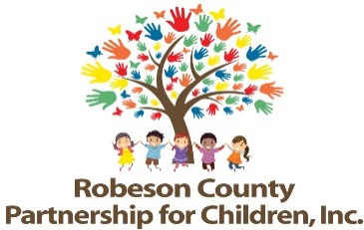

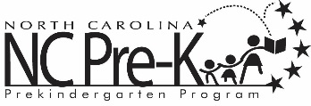
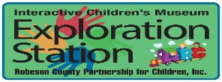

Grants Review Committee Panel Interviews
December 5, 2018
RCPC Board Room
11:00 a.m.

RCPC advertised Request for Proposals (RFP) for the 2019-2021 Grant years. Following submission deadline, the Grants Review Committee and staff conduct panel interview sessions with potential bidders. Once panel interviews are conducted, the Grants Review Committee attends a proposal conference to review, discuss, and score proposals.

