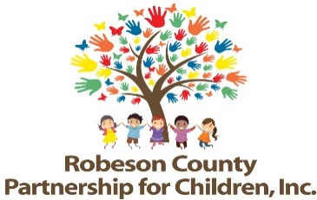

Grants Review Committee Meeting
July 11, 2019
RCPC Board Room
12:00 p.m.

Approval of Minutes
Review minutes from January 10, 2019 Committee meeting.

Committee Overview

Action Items
- Second Quarter Progress Report & Score Card
Background: The Grants Review Committee is responsible for reviewing activity progress.
Issue: The second quarter progress report and score card is included.
Recommendation: The committee should review and consider approving the second quarter progress report and score card.

- Third Quarter Progress Report & Score Card
Background: The Grants Review Committee is responsible for reviewing activity progress.
Issue: The third quarter progress report and score card is included.
Recommendation: The committee should review and consider approving the third quarter progress report and score card.

Non-Action Items

Announcements

Adjournment
The next meeting will be held on Tuesday, September 12, 2019.

