Robeson County Partnership for Children, Inc. (RCPC)
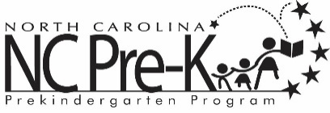

Robeson County NC Pre-K
Site Selection Subcommittee Meeting
September 26, 2019
RCPC Board Room
12:00 PM

The Robeson County NC Pre-K Program is conducting the site selection process for 2020-2022 school years. The Robeson County NC Pre-K Committee appointed a site selection sub-committee to conduct the process. Per DCDEE requirements, the sub-committee must complete an orientation/training session prior to undertaking site selection.

