Robeson County Partnership for Children, Inc. (RCPC)

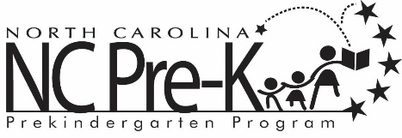

Robeson County NC Pre-K Co-Chair Meeting
April 21, 2020
Via Conference Call
1-717-275-8940 Access Code: 834 1337
Immediately following the NC Pre-K Committee Meeting
that follows the RCPC Board Meeting
*Space will be available whereby members of the public may listen to the meeting at:
Robeson County Partnership for Children, Inc. Board Room
210 E. Second Street
Lumberton, NC 28358

Call to Order

Public Comment

Discussion: Appointment of NC Pre-K Committee members for 2020-2021.

Adjournment

