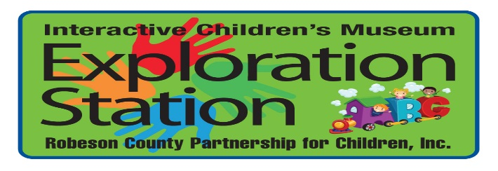

Book your next event with US!!
Looking for an awesome venue for your child’s birthday party? Want to reward your employees with a Family Day? Events held at Exploration Station ensure all your guests are engaged and your smallest guests are learning while they play.

Contact Name _________________________________
Contact Number _________________________________
Contact E-mail _________________________________

*Requested Party Date _________________________________

*Requested Time 11:00 a.m. - 1:00 p.m. 2:00 p.m. – 4:00 p.m.
*Requested Room _________________________________
Birthday Room-Upstairs (Maximum 20 Guests) $125**
Café-Downstairs (Maximum 30 Guests) $150**
*Completion of this form does not guarantee requested dates, times, and rooms will be available. Exploration Station staff will check availability and will try to match your requests as closely as possible. Initial deposit of $70 plus tax will be necessary to reserve selected date, time, and room.
**Applicable sales tax will be added.
Events are held during normal operating hours while Exploration Station is open to the general public. If you are a member and are interested in a private event please contact us at (910) 738-1114 for further information and pricing.
If you have any further questions, please feel free to contact our Front Desk at (910) 738-1114. We are happy to assist with planning your next special event.
Completed forms can be emailed to Donna Hall at dhall@rcpartnership4children.org

