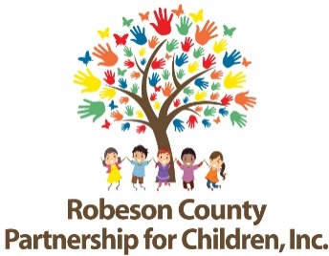
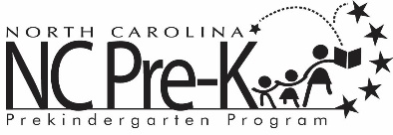

Robeson County Partnership for Children NC Pre-K Contact List
NC Pre-K Contacts | Roles and Responsibilities
Rhiannon Chavis-Wanson  Program Director  910-738-6767 ext. 245  rchaviswanson@rcpartnership4children.org | NC Pre-K Program Management
Victoria Meggison  Program Specialist  910-738-6767 ext. 286  vmeggison@rcpartnership4children.org | Application Approval, Child Placement, Child Transfers, Slot Maintenance
Erika Nolley  NC Pre-K Senior Specialist  910-738-6767 ext. 285  enolley@rcpartnership4children.org | Transportation, Application Approval, Teacher Placement, Technical Assistance
Diana Strickland  NC Pre-K Coordinator  910-738-6767 ext. 292  dstrickland@rcpartnership4children.org | Attendance, Applications,
Nicole Brown  Program Coordinator  910-736-6767 ext. 291  nbrown@rcpartnership4children.org | Applications, Health Assessments, Dental, and Dial 4 Assessments
Amanda Lovette  Quality Enhancement Specialist  910-738-6767 ext. 297  alovette@rcpartnership4children.org | Technical Assistance
Lindsay Mejia  Finance & Contract Specialist  910-738-6767 ext. 224  lmejia@rcpartnership4children.org | Contracts and Reimbursement

For general questions concerning Robeson County’s NC Pre-K program, please contact the receptionist at 910-738-6767.

