Robeson County Partnership for Children, Inc. (RCPC)
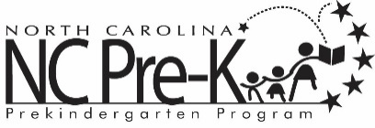

Robeson County NC Pre-K Committee Meeting
April 4, 2023

The NC Pre-K Committee Meeting scheduled for Tuesday, April 4, 2023 has been canceled.

