Robeson County Partnership for Children, Inc. (RCPC)
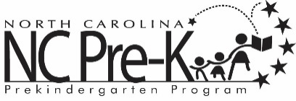

Robeson County NC Pre-K Committee Meeting
April 9, 2024

The NC Pre-K Committee Meeting scheduled for Tuesday, April 9, 2024 has been canceled.

