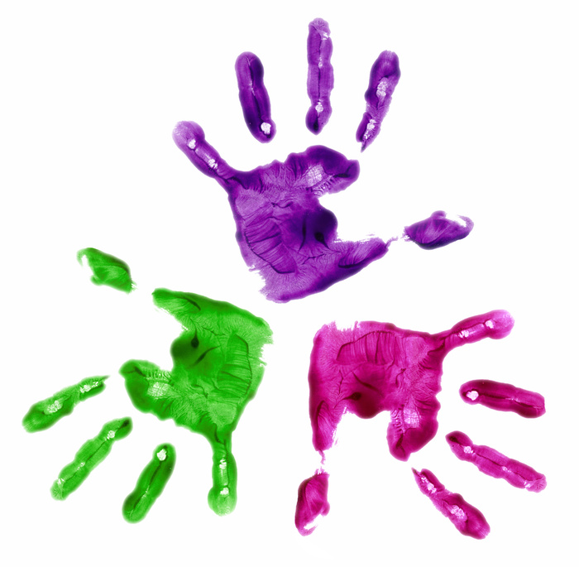
Robeson County Partnership for Children, Inc.
Board of Directors Meeting
Tuesday, August 8, 2023
12:00 p.m.

*RCPC Board and Committee Meetings will be hosted as a hybrid format where public may attend in person or virtually at:

Robeson County Partnership for Children, Inc. Board Room
210 E. Second Street
Lumberton, NC 28358
OR
Via Zoom
https://us06web.zoom.us/j/86777723444?pwd=L2hwd1RST3laTllsNm0vVGFnOSszdz09
Meeting ID: 867 7772 3444
Passcode: 694169
Call In: 1 301 715 8592

AGENDA
Call to Order Marie Clark, Board Chair

Invocation Debra Graham

Mission & Vision Marie Clark

Board Chair Announcements Marie Clark, Board Chair
Public Comment

Consent Agenda Items Marie Clark, Board Chair

Board of Directors
Minutes

Discussion Agenda Items

Ready, Set, Go Activity

Executive Director Report Jessica Lowery Clark, Executive Director
Announcements
Adjournment
If you would like to request accompanying documents, please contact Kari Maynor at
910-738-6767 or kmaynor@rcpartnership4children.org

