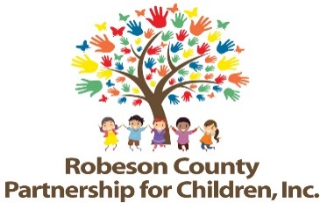

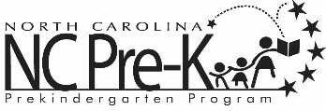
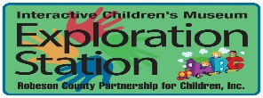


Grants Review Committee Panel Interviews
November 29, 2023
9:00 a.m.
Robeson County Partnership for Children, Inc. Board Room
210 E. Second Street
Lumberton, NC 28358

RCPC advertised Request for Proposals (RFP) for the 2024-2027 grant years. Following submission deadline, the Grants Review Committee and staff conduct panel interview sessions with potential bidders. Once panel interviews are conducted, the Grants Review Committee attends a proposal conference to review, discuss, and score proposals.

