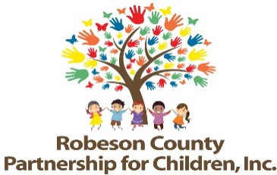

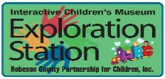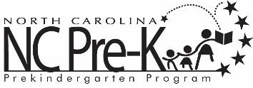

**Grants Review Committee Meeting**

**May 8, 2025**

**1:00 p.m.**

**Committee Meetings will be hosted as a hybrid format where public may attend in person or virtually at:**

**Robeson County Partnership for Children, Inc. Board Room**

**210 E. Second Street**

**Lumberton, NC 28358**

**OR**

**Via Zoom**

[**https://us06web.zoom.us/j/86534306268?pwd=GmgoOraELealao52ywGJOKQo0ZV2o4.1**](https://us06web.zoom.us/j/86534306268?pwd=GmgoOraELealao52ywGJOKQo0ZV2o4.1)

**Meeting ID: 865 3430 6268**

**Passcode: 257593**

**Call In: 1 301 715 8592**

**Approval of Minutes**

Review minutes from the January 9, 2025 committee meeting.

**Action Items**

1. **2nd Qtr. Progress Report & Score Card**

**Background:** The Grants Review Committee is responsible for reviewing activity progress.

**Issue:** The 2024-2025 second quarter progress report and score card is included.

**Recommendation:** The committee should review and consider approving the second quarter report and score card.

1. **New Activity and Contract Activity Description-Dolly Parton Imagination Library (DPIL)**

**Background:** The Grants Review Committee must review and recommend any new activities before placing into contract.

**Issue:** Funds are available for new programming in the 25-26 fiscal year due to the loss of activities. Per North Carolina Partnership for Children, DPIL does not require bidding due to the national program model that only allows one affiliate per county. Lumber River United Way is the affiliate for Robeson County.

**Recommendation:** It is recommended that the Committee consider approving the addition of Dolly Parton Imagination Library to the FY 2025-2026 Contract Package.

**Non-Action Items**

**Announcements**

**Adjournment**

The next meeting will be held on July 10, 2025.