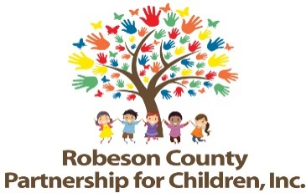

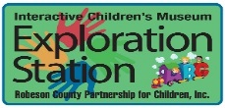

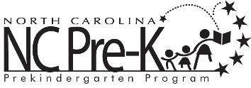

Grants Review Committee Meeting
January 8, 2026
1:00 p.m.
Committee Meetings will be hosted as a hybrid format where public may attend in person or virtually at:
Robeson County Partnership for Children, Inc. Board Room
210 E. Second Street
Lumberton, NC 28358
OR
Via Zoom
https://us06web.zoom.us/j/86534306268?pwd=GmgoOraELealao52ywGJOKQo0ZV2o4.1

Meeting ID: 865 3430 6268
Passcode: 257593
Call In: 1 301 715 8592

Approval of Minutes
Review minutes from the September 11, 2025 committee meeting.

Action Items

- 1st Qtr. Progress Report & Score Card
Background: The Grants Review Committee is responsible for reviewing activity progress.
Issue: The 2025-2026 first quarter progress report and score card is included.
Recommendation: The committee should review and consider approving the first quarter report and score card.

Non-Action Items

Announcements

Adjournment
The next meeting will be held on March 12, 2026.

