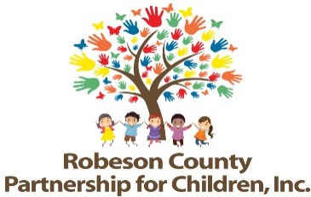

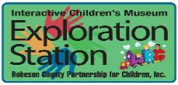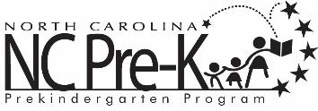

**Grants Review Committee Meeting**

**July 10, 2025**

**1:00 p.m.**

**Committee Meetings will be hosted as a hybrid format where public may attend in person or virtually at:**

**Robeson County Partnership for Children, Inc. Board Room**

**210 E. Second Street**

**Lumberton, NC 28358**

**OR**

**Via Zoom**

[**https://us06web.zoom.us/j/86534306268?pwd=GmgoOraELealao52ywGJOKQo0ZV2o4.1**](https://us06web.zoom.us/j/86534306268?pwd=GmgoOraELealao52ywGJOKQo0ZV2o4.1)

**Meeting ID: 865 3430 6268**

**Passcode: 257593**

**Call In: 1 301 715 8592**

**Approval of Minutes**

Review minutes from the May 8, 2025 committee meeting.

**Action Items**

1. **New Activity -Robeson County Diaper Bank**

**Background:** The Grants Review Committee must review and recommend any new activities before placing into contract.

**Issue:** Funds are available for new programming in the 25-26 fiscal year due to the loss of activities. An RFA was advertised for Diaper Bank of NC and Robeson County Partnership for Children was the only bidder.

**Recommendation:** It is recommended that the Committee review the application and consider approving the addition of Robeson County Diaper Bank to the FY 2025-2026 Contract Package.

**Non-Action Items**

**Announcements**

**Adjournment**

The next meeting will be held on September 11, 2025.