Robeson County Partnership for Children, Inc. (RCPC)
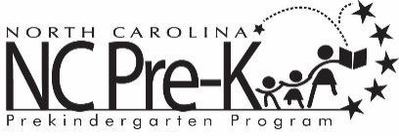

Robeson County NC Pre-K Committee Meeting
April 14, 2026

The NC Pre-K Committee Meeting scheduled for Tuesday, April 14, 2026 has been canceled.

