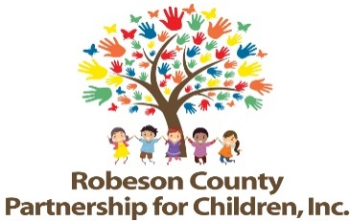

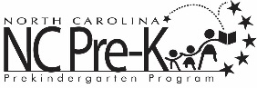
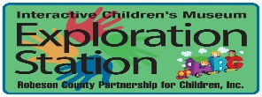


Nominations/Personnel Committee Meeting
April 1, 2026
Committee Meetings will be hosted as a hybrid format where public may attend in person at:
Robeson County Partnership for Children, Inc. Board Room
210 E. Second Street
Lumberton, NC 28358
OR
Virtually Via Zoom:
https://us06web.zoom.us/j/89741659867?pwd=bJdfNsCbetcwEKyobni8TjHPKzHLaH.1
Meeting ID: 897 4165 9867
Passcode: 499080
Call In: 1 301 715 8592
12:00 p.m.

Approval of Minutes
Review minutes from March 26, 2025 committee meeting.

Action Items
- FY 2025-2026 Annual Review of Employee Handbook
Background: A review of the Employee Handbook is conducted on an annual basis as a measure of best practice.

Issue: There are no recommended changes at this time.

Recommendation: It is recommended that the committee discuss and consider approving the FY 25-26 Annual Review of the Employee Handbook without changes.

- FY 2026-2027 Board Slate
Background: The Board of Directors must approve the slate each year.

Issue: The proposed FY 2026-2027 board slate is attached.

Recommendation: It is recommended that the committee review and consider approving the FY 2026-2027 board slate.

Non-Action Items

Announcements
Adjournment

