Robeson County Partnership for Children, Inc. (RCPC)
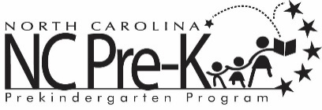

Robeson County NC Pre-K Committee Meeting
August 11, 2026
12:00 PM
Committee Meetings will be hosted as a hybrid format where public may attend in person at:

Robeson County Partnership for Children, Inc. Board Room
210 E. Second Street
Lumberton, NC 28358

OR

Via Zoom
https://us06web.zoom.us/j/88259091362?pwd=4b2aGjeHL0ffSm1OCTYSSNyhGancHu.1
Meeting ID: 882 5909 1362
Passcode: 146471
Call In: 1-301-715-8592
Call to Order

Public Comment

Approval of Minutes
Review minutes from the June 9, 2026 committee meeting.

Action Items

- Annual Review of the Robeson County NC Pre-K Policies, Procedures, and Practices

Background: The Committee must approve any revisions to the policies, procedures, & practices. These policies include the requirements for the Committee to review, discuss and approve written plans, fees, and the authority for contracting agency to reallocate slots across NC Pre-K sites without Committee approval.

Issue: There are no recommended changes at this time.

Recommendation: It is recommended that the committee consider approving the annual review of the NC Pre-K policies and procedures with the recommended changes.

Non-Action Items
- Community & Recruitment Update – Erika Nolley
- ECERS Update – Erika Nolley
- Placement Update –Erika Nolley
- Site Updates – Erika Nolley
- Updates from DCDEE – Erika Nolley
- Assurances & Requirements – Erika Nolley
- Year to Date Financial Report – Lindsay Mejia

Next Meeting Date: The next committee meeting is scheduled for October 13, 2026 upon the adjournment of the Smart Start Board of Directors Meeting.

Adjournment

