Robeson County Partnership for Children, Inc. (RCPC)

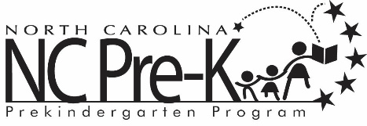

Robeson County NC Pre-K Co-Chair Meeting
June 9, 2026
Immediately following the NC Pre-K Committee Meeting
*NC Pre-K Co-Chair Meetings will be hosted as a hybrid format where public may attend in person or virtually at:
Robeson County Partnership for Children, Inc. Conference Room
210 E. Second Street
Lumberton, NC 28358
OR
Via Zoom
https://us06web.zoom.us/j/86961534532?pwd=K5NMxLTetB15QDFpDozGYSxd9JOXw6.1

Meeting ID: 869 6153 4532

Passcode: 448090

Call In: 1 301 715 8592

Call to Order

Public Comment

Discussion: Appointment of NC Pre-K Committee members for 2026-2027.

Adjournment

